Ideation Phase
Brainstorm & Idea Prioritization Template
Date | 03 October 2026
Team ID | SWTID-2026-7282
Project Name | Implement Client Script & UI Policy (Incident)
Maximum Marks | 4 Marks
Brainstorm & Idea Prioritization Template:
Brainstorming provides a free and open environment for team members to contribute ideas that can lead to problem solving. Ideas are generated first, grouped into themes, and then prioritized based on their importance and feasibility.
For this project, the brainstorming activity focuses on improving the ServiceNow Incident form through dynamic field behaviour, better data entry control, and improved user experience.
Reference: https://www.mural.co/templates/brainstorm-and-idea-prioritization
Step-1: Team Gathering, Collaboration and Select the Problem Statement
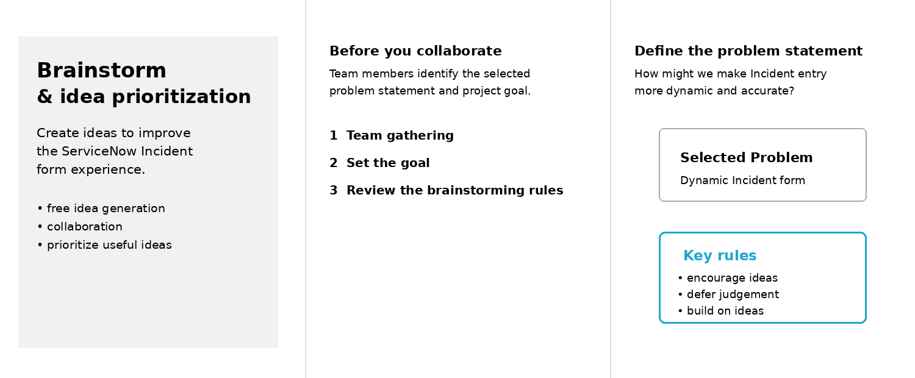

Step-2: Brainstorm, Idea Listing and Grouping
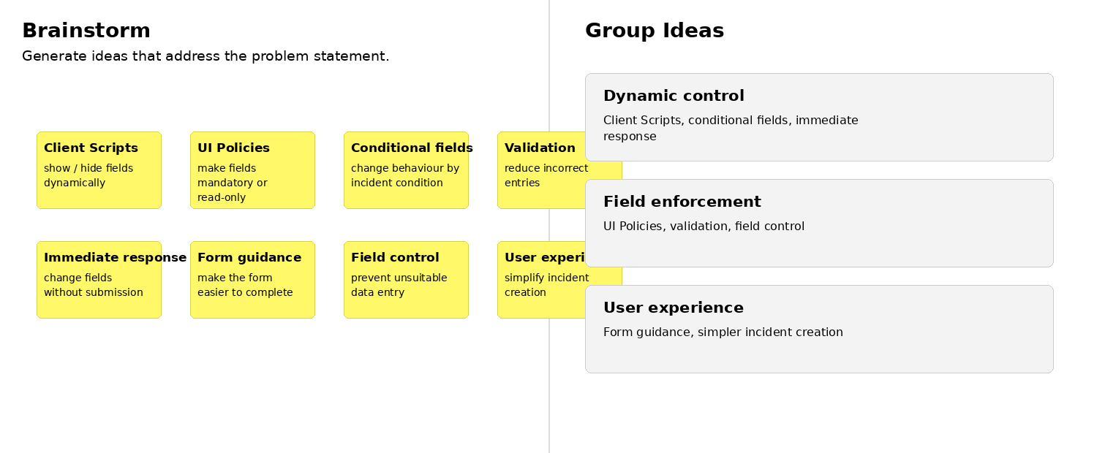
Step-3: Idea Prioritization
